Confucius Movie Clips Quiz
Directions: Watch each short movie clip, then answer the question using evidence from the movie (or other sources used in class) to back up your answer.
Clip One | Why does Confucius insist upon bowing before entering the palace, even though he is not required to do so?
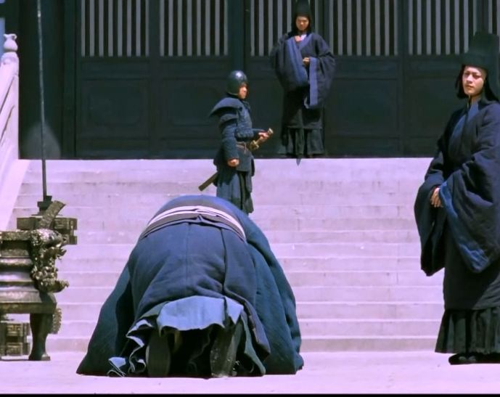
Clip Two | What argument did Confucius make for saving Qigong's (the slave boy) life and how does his reason relate to his philosophy of respect for the Duke of Zhou?
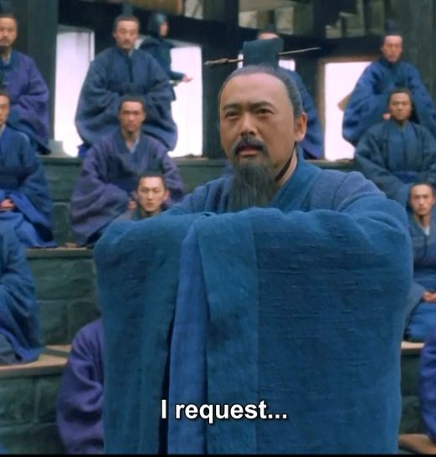
Clip Three | What objections does Confucius have to the way Biyi governs its people and how would he rather all kingdoms govern their people?
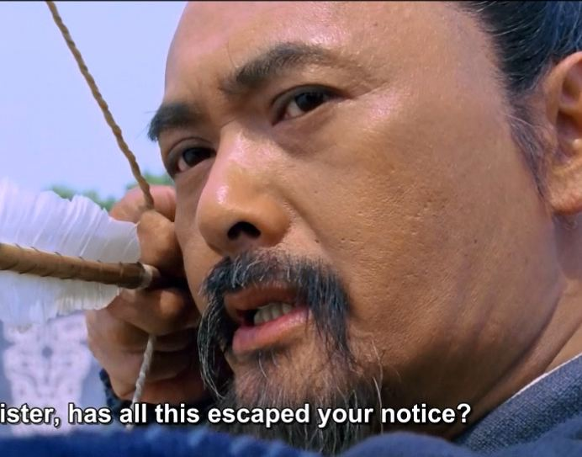
Clip Four | Why does Confucius insist that Duke Ding wait for the Duke of Qi to descend the platform to greet them? Why are these customs and rituals important to Confucius?
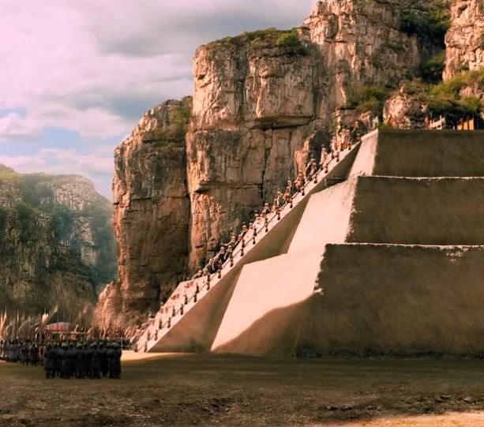
Clip Five | Why is it important to Confucius that the city walls inside the kingdom of Lu be lowered? (Think of Confucian relationships and his philosophy on governing.)
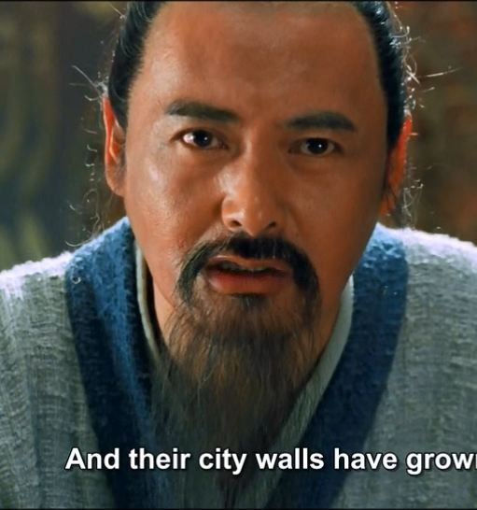
Clip Six | Why did Duke Ding reject Confucius and why might it have been difficult for rulers to govern the way Confucius wanted them to? Also, what advice did Laozi, the founder of Taoism, have for Confucius and his predicament at the time?

Clip Seven | Confucius has lost his position in the Lu Court. Rather than dwelling in failure, what does Yan Hui suggest and why is this important to Confucianism?
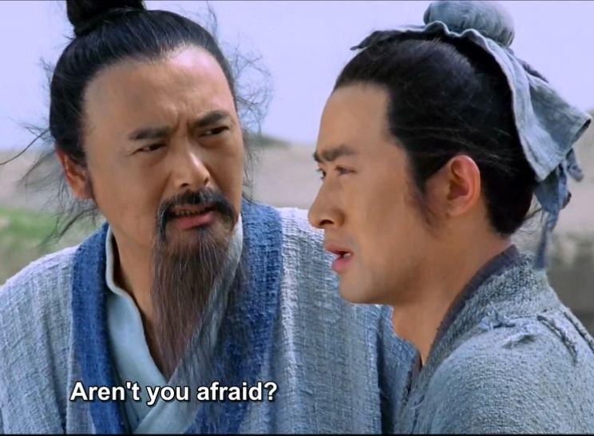
Clip Eight | Why is Confucius bothered by the actions of the Royal Consort Nanzi as it relates to Li (Ritual)?
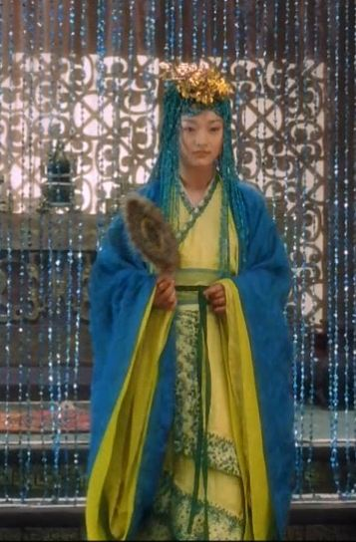

Clip Nine | Quiz Question: Yan Hui quotes Confucius saying, "Only in winter does the pine tree show its true strength." What is the meaning of this saying and how does it relate to main tenets (foundations) of Confucianism?
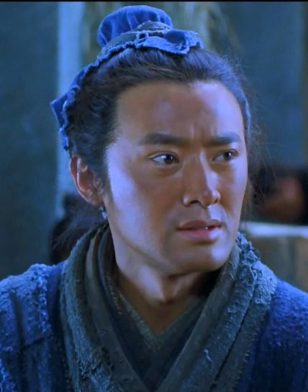
Clip Ten | Based on his teachings, why is it very important to Confucius come back to his hometown of Lu?
